27/02/24 **Lecture 6: Deep Learning**

Deep Learning Development and Deployment Growth

• Rapid growth in Deep Learning development since 2006.

• Reimagined MultiLayer Perceptrons with new technical breakthroughs.

• GPUs used for practical training of large networks.

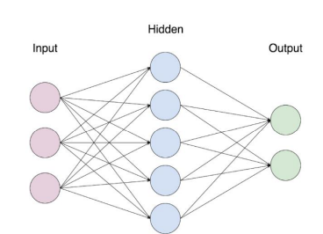

Machine learning

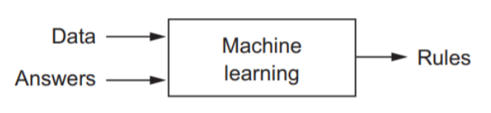

Machine Learning uses algorithms to perform tasks without explicit programming, while Deep Learning uses complex algorithms modelled on the human brain to process unstructured data.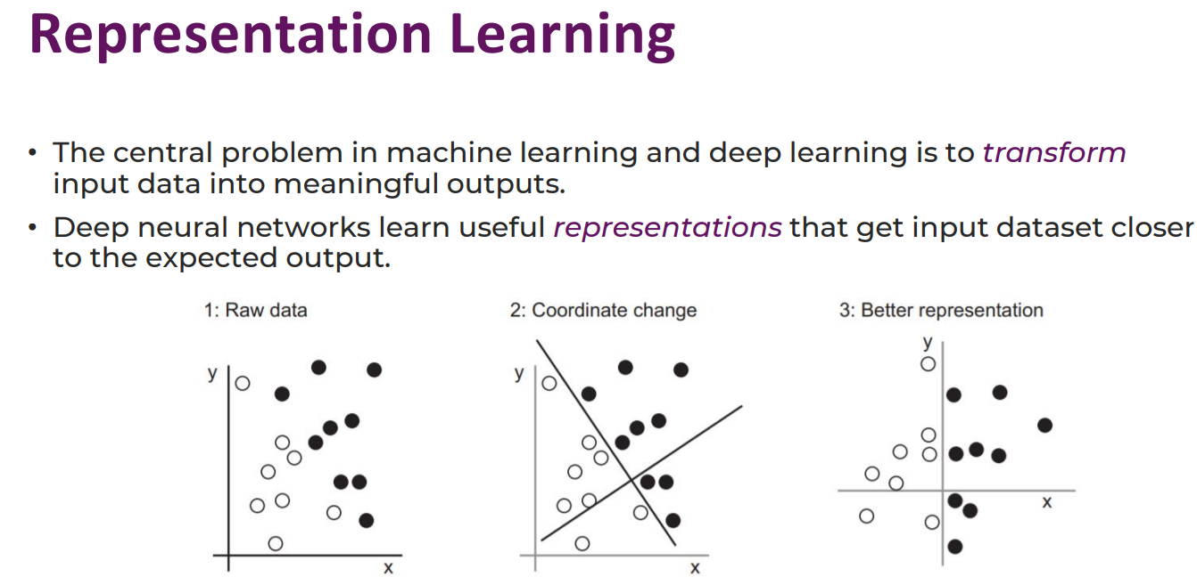

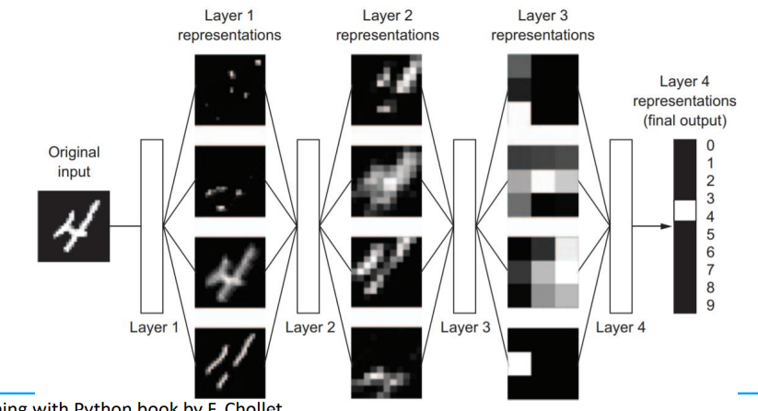

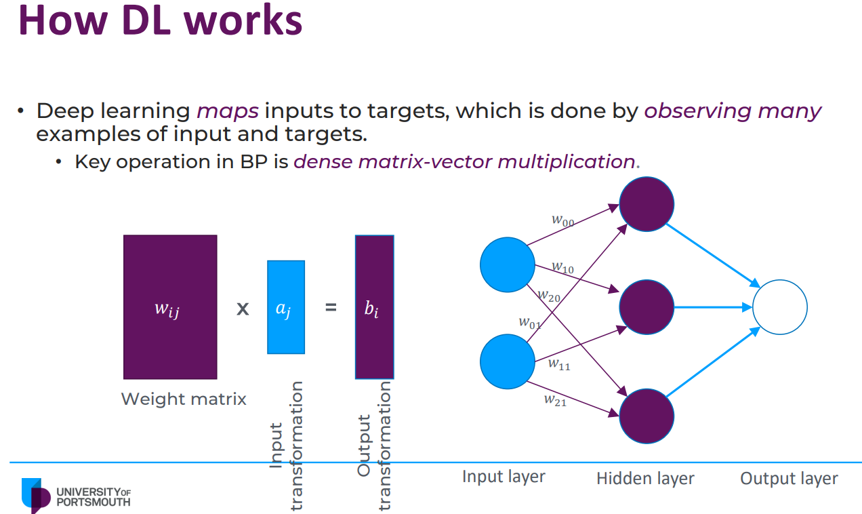

• Subset of machine learning using artificial neural networks.

• Networks consist of interconnected nodes, hidden layers, weights, biases, activation functions, forward propagation, loss function, and backpropagation.

• Aim to minimize predicted vs actual outputs.

• Adjusts weights and biases for improved prediction accuracy.

How weight is adjusted:

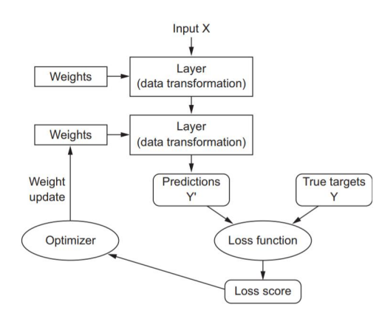

Activation function

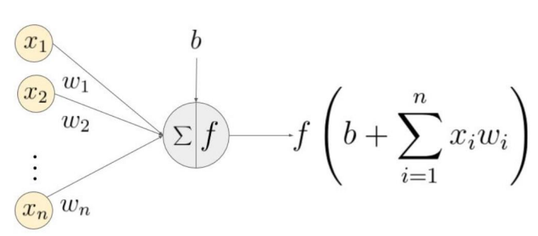

Linear Operations in Neuronal Networks

• Combines linear operations for linear output.

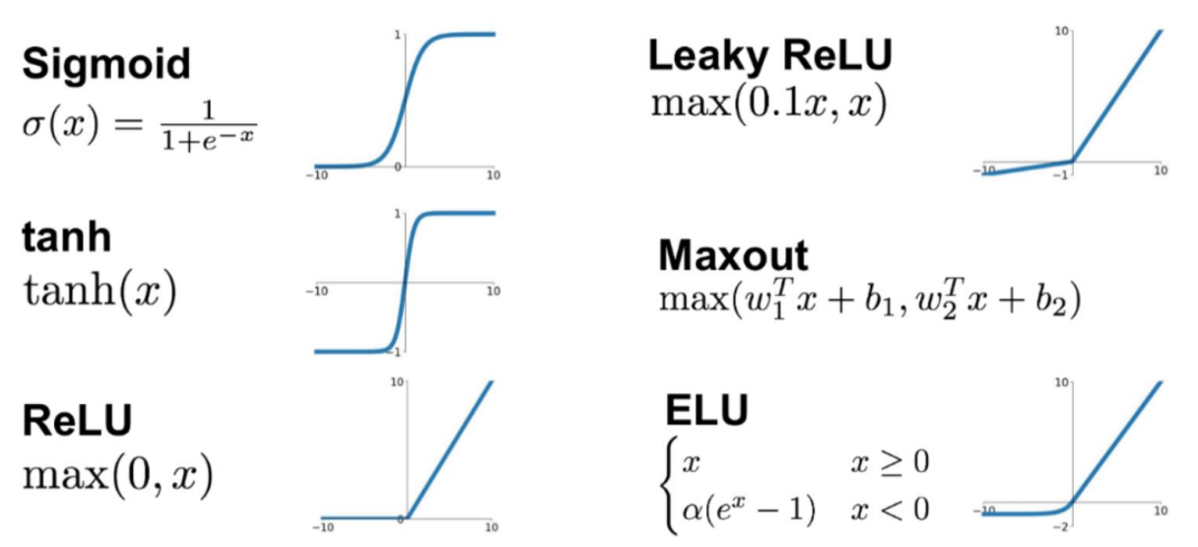

• Non-linear behavior requires non-linear term in mix.

• Non-linear activation function applied to summed inputs of neurons in hidden layers.

Convolutional neural network (CNN)

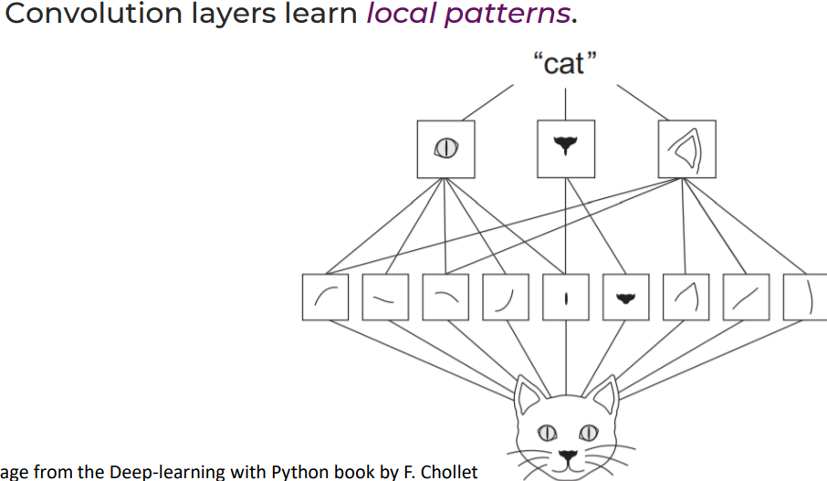

A dense neural network connects every neuron in one layer to every neuron in the next, while modern computer vision networks have specialised connectivity for early processing layers. Convolutions are organised in convolutional layers for localised value computation.

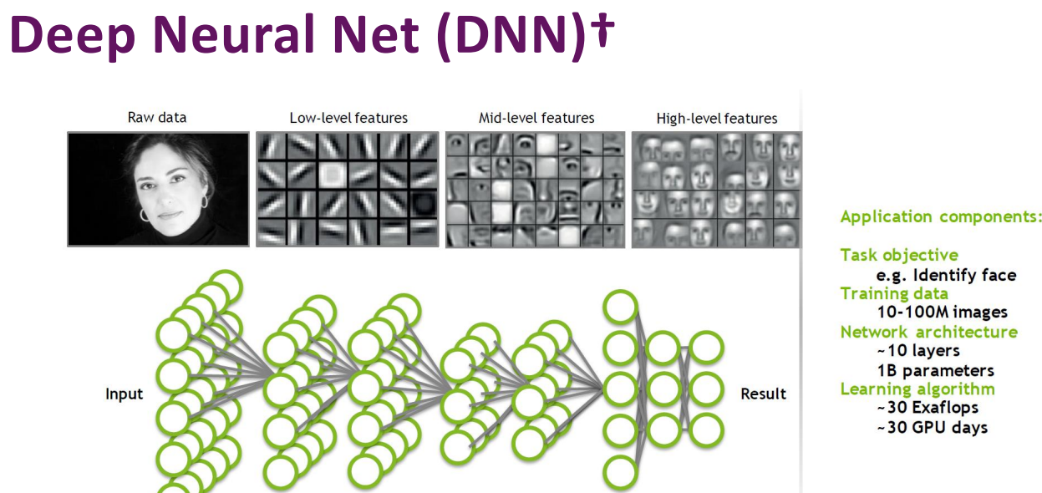

TensorFlow Overview

• Google uses tensors to represent dense multi-dimensional arrays of numbers.

• Tensors are data containers in current machine learning systems.

• 1D tensors represent vectors holding data like age, ZIP code, and income.

• 2D tensors represent grayscale images as 2D matrix of numbers.

• Google's TensorFlow is a symbolic manipulation package for tensor values.

• Keras library offers a Python interface for TensorFlow.